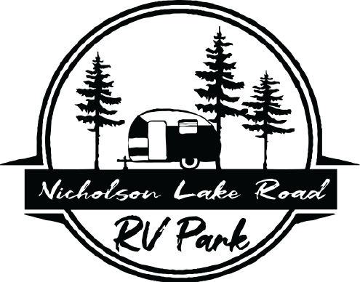

2022 Bar-B-Que Cookoff Entry Form

_________________________________________
Name of team (Please print clearly.)
________________________________________________ DOB ____________
Name of Chief Cook (Please print clearly.)
________________________________ _______________ ____ _____________
Mailing Address City State Zip Code
(____)_______________ _____________________________________
Phone Number Email
Team Members:
2) Name____________________________ Phone _______________
Email ________________________ DOB ______________
3) Name____________________________ Phone _______________
Email ________________________ DOB ______________
4) Name____________________________ Phone _______________
Email ________________________ DOB ______________
5) Name____________________________ Phone _______________
Email ________________________ DOB ______________

**By signing below you and your team members all agree to the rules of the Nicholson Lake Road RV Park Cookoff.**

_____________________ ___________________ ___________
Signature of Chief Cook Print Name of Chief Cook Date

**Entry fees are non-refundable unless the event is canceled.**

Categories: Beef Brisket Chicken Pork Spare Ribs
Fee: $150.00 (includes entry in all three categories above)
Entry Deadline: October 14, 2022 ($175.00 after deadline

Bloody Mary Contest $25.00 ______
Chef’s Choice $25.00 ______ *See rule sheet for Chef’s Choice.*

DO NOT WRITE BELOW THIS LINE. STAFF USE ONLY.

Amount paid $____________ Check # _______ Cash_________

Accepted by _______________________

Checks are to be made out to: NL Rd RV Park
All completed forms can be mailed or dropped off at:
4200 Nicholson Lake Road
Chappell Hill, TX 77426

Nicholson Lake Road Bar-B-Que Cookoff

The Nicholson Lake Road RV Park, including its officers, superintendents, servants, agents and/or employed ,herein called Nicholson Lake Road RV Park., and the owner and/or exhibitor or contestant, including parents, and/or legal representatives, herein called, exhibitor, agree that Nicholson Lake Road RV Park will in no case be responsible for loss, damages, or injury to the person, animals or property of the exhibitor’s or exhibitor’s agent, servants, family and/or employees, regardless of how such loss, damages or injury is occasioned and by whom. Nicholson Lake Road RV Park and exhibitor further agree that exhibitor will protect, indemnify and defense of any such claims, suits, judgments (including the cost of defense of any such claim) and or suit by Nicholson Lake Road RV Park brought by anyone as a result of any loss, damage or injury to any person, animals or property occasioned by any action or inaction of exhibitor either solely or in conjunction with Nicholson Lake Road RV Park or anyone else.

Contestant agrees to abide by all Rules and Regulation, published or otherwise presented, of Nicholson Lake Road RV Park.

The chief cook will be responsible for the conduct of the team and guests.

_________________________________________________ ___________
Chief Cook Signature Date
__________________________________________________
Print Name

