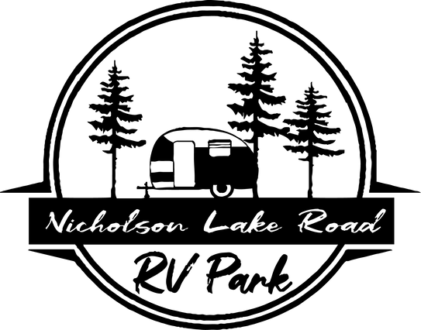
BBQ CONTEST RULES October 21st & 22nd, 2022

- Spaces will be assigned on a first received basis, NO EXCEPTION! If you wish to be assigned a particular space, you must fill out the space reservation form and return it to the RV Park Office along with your application and entry fee. The cook-off area layout is subject to change.

- Early applications are due in the RV Park Office by October 14, 2022 ($150.00); late entries will be accepted until 8:00 p.m. on Friday, October 21, 2022. All Late entries must be paid by cash only ($175.00).

- There is no access to electricity and running water. Plan to provide your own shade and bring a generator.

- Chef’s Choice entries must be cooked from scratch, on the grounds, on a bar-be-cue pit. Please provide 7 pieces of your choice of the same thing for your entry.

- Bloody Mary’s – You must provide 16 oz of your Bloody Mary. We will provide you with a cup.

- The meat from which entries are to be taken will not be allowed on grills before meat is inspected by the committee. Meat inspection will be 4:00 p.m. to 8:00 p.m. on Friday. Pre-cooked, salted, seasoned or marinated meat is not allowed. Each contestant may cook two separate pieces of the type of meat it submits as its entry (e.g., two slabs of ribs, two chickens or two briskets). If a contestant elects to cook two pieces of meat both pieces must be inspected and tagged by the Committee’s meat inspectors. All meat can be cooked with sauce but may not be turned in with any sauce.

- Brisket – 7 full pieces no less than ¼” thick placed in the box running horizontally with the box hinge. Slices cut in half will receive an automatic point of zero.
- Ribs – 7 pork spare ribs full or St. Louis style ran parallel to the box hinge. Baby back ribs are not allowed and will receive an automatic point of zero.
- Chicken – 7 pieces of thighs with the skin on in pieces placed in box to fit, undercooked chicken will receive an automatic point of zero. Must not be boneless or skinless.

- There may be two head cooks per pit; each head cook MUST have their own meat for turn-in. If multiple entries are turned in from the same meat, it will be grounds for disqualification. A BBQ pit may include gas or electricity ONLY to start the combustion of wood. Contestants’ pits may be inspected for conformity. All fires must be of wood or wood substance. All fires must be in containers, not on the ground. Holes, dug pits, or open flames in boxes or other containers resting on or less than two feet above the surface are not permitted. Open flames of any kind are NOT permitted (e.g., tiki torches or campfires.) All pits must be diapered to prevent coal or grease damage to the parking lot surface.

- Contestants will be allowed to sell barbecue if they choose to on Saturday only.

- No keg beer allowed on grounds - can beer only. Excessive use of alcoholic beverages will be grounds for disqualification. Please observe state liquor laws. The serving of alcoholic beverages to minors is strictly prohibited and will result in disqualification.

- Sound amplification should be used in moderation during the entire cook-off and must be turned off from midnight Friday until 8:00 a.m. Saturday. This rule will be strictly enforced and refusal to abide will result in immediate disqualification and eviction from the grounds.

- No skateboards, tricycles, bicycles, motorcycles, mopeds, three/four- wheelers, or golf carts will be permitted inside the cook-off area by Teams, Their Guests, or Spectators. Absolutely no pets allowed.

- It is suggested that you bring suitable shelter as the weather may require. RAIN OR SHINE - the contest will go on.

- Each team will be responsible for cleaning up their space. Hot coals and ashes should be disposed of in containers provided for them (not on the ground or in regular trash cans). The chief cook will be responsible for the conduct of his/her team.

- All contestants and equipment must be off the grounds by Noon on Sunday, Oct 23, 2022

- Nicholson Lake RV Park and committee reserves the right to make additional regulations as situations warrant. Decisions of the committee and Nicholson Lake RV Park will be final.

- Nicholson Lake RV Park, committee members, and sponsors will not be liable for theft, damages, or any accidents.
- Nicholson Lake RV Park rules for the events are to be followed by all contestants & will be enforced by the Nicholson Lake RV Park coordinator.

SCHEDULE: **FREE ADMISSION ALL WEEKEND**
Thursday, October 20th
Early Set-up Only 5:00 p.m. to 8:00 p.m.

Friday, October 21st

Gates Open 10:00 a.m. Check-in 10:00 a.m. to 6:00 p.m.
Meat Inspection 4:00 p.m. to 8:00 p.m.
* Chief Cooks Meeting * 5 PM – 6 PM
Chefs Choice 7 PM
CrossRoads Live Band 7 PM to 10 PM

Saturday, October 22nd
Bloody Mary 10 AM
Chicken 1 PM
Ribs 2 PM
Brisket 4 PM
Awards 6:00 p.m.
Gates Lock 1:00 a.m.

Saturday, October 22nd
All contestants and equipment must be off the grounds by 12 noon

AWARDS: Sample: Cash awards & Trophies will be given to 1 st , 2 nd, & 3rd places. 4 th thru 10th place winners will receive points toward Overall Grand Champion. Highest points in only the 3 meat categories will be used for overall. In case of tie - brisket will be the tie breaker category. All cash prizes will be based on the number of paid entries.

Best of Show/Hospitality Sample:**Best of Show/Hospitality Winner will receive free entry into next year’s contest. Judging will be Friday and Saturday and based on generosity, giveaways to the general public, creativity of decorations, costumes, etc., & your team’s Fair spirit.

